**Prac 4A: insert into blob**

import java.awt.Image;

import java.io.File;

import java.io.FileInputStream;

import java.io.FileNotFoundException;

import java.io.InputStream;

import java.sql.Connection;

import java.sql.DriverManager;

import java.sql.PreparedStatement;

import java.sql.SQLException;

import java.util.logging.Level;

import java.util.logging.Logger;

import javax.swing.ImageIcon;

import javax.swing.JFileChooser;

import javax.swing.JOptionPane;

import javax.swing.filechooser.FileNameExtensionFilter;

/*

* To change this license header, choose License Headers in Project Properties.

* To change this template file, choose Tools | Templates

* and open the template in the editor.

*/

/**

*

* @author bot

*/

public class blob extends javax.swing.JFrame {

String s =new String("");

/**

* Creates new form blob

*/

public blob() {

initComponents();

}

/**

* This method is called from within the constructor to initialize the form.

* WARNING: Do NOT modify this code. The content of this method is always

* regenerated by the Form Editor.

*/

@SuppressWarnings("unchecked")

// <editor-fold defaultstate="collapsed" desc="Generated Code">

private void initComponents() {

jLabel1 = new javax.swing.JLabel();

jButton1 = new javax.swing.JButton();

jLabel2 = new javax.swing.JLabel();

jLabel3 = new javax.swing.JLabel();

jTextField1 = new javax.swing.JTextField();

jTextField2 = new javax.swing.JTextField();

jLabel4 = new javax.swing.JLabel();

jButton2 = new javax.swing.JButton();

jScrollPane1 = new javax.swing.JScrollPane();

jTextArea1 = new javax.swing.JTextArea();

setDefaultCloseOperation(javax.swing.WindowConstants.EXIT_ON_CLOSE);

jButton1.setText("Add to database");

jButton1.addActionListener(new java.awt.event.ActionListener() {

public void actionPerformed(java.awt.event.ActionEvent evt) {

jButton1ActionPerformed(evt);

}

});

jLabel2.setText("Id");

jLabel3.setText("Name");

jLabel4.setText("Description");

jButton2.setText("Browse");

jButton2.addActionListener(new java.awt.event.ActionListener() {

public void actionPerformed(java.awt.event.ActionEvent evt) {

jButton2ActionPerformed(evt);

}

});

jTextArea1.setColumns(20);

jTextArea1.setRows(5);

jScrollPane1.setViewportView(jTextArea1);

javax.swing.GroupLayout layout = new javax.swing.GroupLayout(getContentPane());

getContentPane().setLayout(layout);

layout.setHorizontalGroup(

layout.createParallelGroup(javax.swing.GroupLayout.Alignment.LEADING)

.addGroup(layout.createSequentialGroup()

.addContainerGap()

.addComponent(jLabel1, javax.swing.GroupLayout.DEFAULT_SIZE, javax.swing.GroupLayout.DEFAULT_SIZE, Short.MAX_VALUE)

.addContainerGap())

.addGroup(javax.swing.GroupLayout.Alignment.TRAILING, layout.createSequentialGroup()

.addContainerGap(38, Short.MAX_VALUE)

.addGroup(layout.createParallelGroup(javax.swing.GroupLayout.Alignment.LEADING)

.addGroup(layout.createSequentialGroup()

.addComponent(jButton2)

.addPreferredGap(javax.swing.LayoutStyle.ComponentPlacement.RELATED)

.addGroup(layout.createParallelGroup(javax.swing.GroupLayout.Alignment.TRAILING)

.addComponent(jLabel3)

.addGroup(layout.createSequentialGroup()

.addGap(23, 23, 23)

.addComponent(jLabel2)))

.addGap(18, 18, 18)

.addGroup(layout.createParallelGroup(javax.swing.GroupLayout.Alignment.LEADING, false)

.addComponent(jTextField1)

.addComponent(jTextField2, javax.swing.GroupLayout.PREFERRED_SIZE, 101, javax.swing.GroupLayout.PREFERRED_SIZE))

.addGap(28, 28, 28)

.addComponent(jLabel4)

.addGap(18, 18, 18)

.addComponent(jScrollPane1, javax.swing.GroupLayout.PREFERRED_SIZE, javax.swing.GroupLayout.DEFAULT_SIZE, javax.swing.GroupLayout.PREFERRED_SIZE))

.addGroup(layout.createSequentialGroup()

.addGap(174, 174, 174)

.addComponent(jButton1)))

.addGap(31, 31, 31))

);

layout.setVerticalGroup(

layout.createParallelGroup(javax.swing.GroupLayout.Alignment.LEADING)

.addGroup(layout.createSequentialGroup()

.addContainerGap()

.addComponent(jLabel1, javax.swing.GroupLayout.DEFAULT_SIZE, 302, Short.MAX_VALUE)

.addPreferredGap(javax.swing.LayoutStyle.ComponentPlacement.RELATED)

.addGroup(layout.createParallelGroup(javax.swing.GroupLayout.Alignment.LEADING)

.addComponent(jButton2)

.addGroup(layout.createSequentialGroup()

.addGroup(layout.createParallelGroup(javax.swing.GroupLayout.Alignment.BASELINE)

.addComponent(jLabel2)

.addComponent(jTextField1, javax.swing.GroupLayout.PREFERRED_SIZE, javax.swing.GroupLayout.DEFAULT_SIZE, javax.swing.GroupLayout.PREFERRED_SIZE)

.addComponent(jLabel4))

.addPreferredGap(javax.swing.LayoutStyle.ComponentPlacement.UNRELATED)

.addGroup(layout.createParallelGroup(javax.swing.GroupLayout.Alignment.BASELINE)

.addComponent(jLabel3)

.addComponent(jTextField2, javax.swing.GroupLayout.PREFERRED_SIZE, javax.swing.GroupLayout.DEFAULT_SIZE, javax.swing.GroupLayout.PREFERRED_SIZE)))

.addComponent(jScrollPane1, javax.swing.GroupLayout.PREFERRED_SIZE, 103, javax.swing.GroupLayout.PREFERRED_SIZE))

.addGap(14, 14, 14)

.addComponent(jButton1)

.addGap(25, 25, 25))

);

pack();

}// </editor-fold>

private void jButton2ActionPerformed(java.awt.event.ActionEvent evt) {

// TODO add your handling code here:

JFileChooser j= new JFileChooser();

j.setCurrentDirectory(new File(System.getProperty("user.home")));

FileNameExtensionFilter filter= new FileNameExtensionFilter("*.IMAGE","jpg","gif","png");

j.addChoosableFileFilter(filter);

int result=j.showSaveDialog(this);

if(result==JFileChooser.APPROVE_OPTION){

File selectedFile=j.getSelectedFile();

String path=selectedFile.getAbsolutePath();

jLabel1.setIcon(ResizeImage(path));

s = path;

}

else if(result==JFileChooser.CANCEL_OPTION){

System.out.println("No Data");

}

}

private void jButton1ActionPerformed(java.awt.event.ActionEvent evt) {

// TODO add your handling code here:

try {

// TODO add your handling code here:

Connection con=DriverManager.getConnection("jdbc:mysql://localhost:3306/loginform?autoReconnect=true&useSSL=false","root","root");

PreparedStatement stmt=con.prepareStatement("insert into myImages(ID,NAME,Description,Image) values(?,?,?,?);");

InputStream is=new FileInputStream(new File(s));

stmt.setInt(1, Integer.parseInt(jTextField1.getText()));

stmt.setString(2, jTextField2.getText());

stmt.setString(3,jTextArea1.getText());

stmt.setBlob(4,is);

stmt.executeUpdate();

JOptionPane.showMessageDialog(null,"Data Inserted");

}

catch (SQLException ex) {

Logger.getLogger(blob.class.getName()).log(Level.SEVERE, null, ex);

}

catch (FileNotFoundException ex) {

Logger.getLogger(blob.class.getName()).log(Level.SEVERE, null, ex);

}

}

public ImageIcon ResizeImage(String imgPath){

ImageIcon MyImage=new ImageIcon(imgPath);

Image img=MyImage.getImage();

Image newImage=img.getScaledInstance(jLabel1.getWidth(),jLabel1.getHeight(),Image.SCALE_SMOOTH);

ImageIcon image=new ImageIcon(newImage);

return image;

}

/**

* @param args the command line arguments

*/

public static void main(String args[]) {

/* Set the Nimbus look and feel */

//<editor-fold defaultstate="collapsed" desc=" Look and feel setting code (optional) ">

/* If Nimbus (introduced in Java SE 6) is not available, stay with the default look and feel.

* For details see http://download.oracle.com/javase/tutorial/uiswing/lookandfeel/plaf.html

*/

try {

for (javax.swing.UIManager.LookAndFeelInfo info : javax.swing.UIManager.getInstalledLookAndFeels()) {

if ("Nimbus".equals(info.getName())) {

javax.swing.UIManager.setLookAndFeel(info.getClassName());

break;

}

}

} catch (ClassNotFoundException ex) {

java.util.logging.Logger.getLogger(blob.class.getName()).log(java.util.logging.Level.SEVERE, null, ex);

} catch (InstantiationException ex) {

java.util.logging.Logger.getLogger(blob.class.getName()).log(java.util.logging.Level.SEVERE, null, ex);

} catch (IllegalAccessException ex) {

java.util.logging.Logger.getLogger(blob.class.getName()).log(java.util.logging.Level.SEVERE, null, ex);

} catch (javax.swing.UnsupportedLookAndFeelException ex) {

java.util.logging.Logger.getLogger(blob.class.getName()).log(java.util.logging.Level.SEVERE, null, ex);

}

//</editor-fold>

/* Create and display the form */

java.awt.EventQueue.invokeLater(new Runnable() {

public void run() {

new blob().setVisible(true);

}

});

}

// Variables declaration - do not modify

private javax.swing.JButton jButton1;

private javax.swing.JButton jButton2;

private javax.swing.JLabel jLabel1;

private javax.swing.JLabel jLabel2;

private javax.swing.JLabel jLabel3;

private javax.swing.JLabel jLabel4;

private javax.swing.JScrollPane jScrollPane1;

private javax.swing.JTextArea jTextArea1;

private javax.swing.JTextField jTextField1;

private javax.swing.JTextField jTextField2;

// End of variables declaration

}

Output

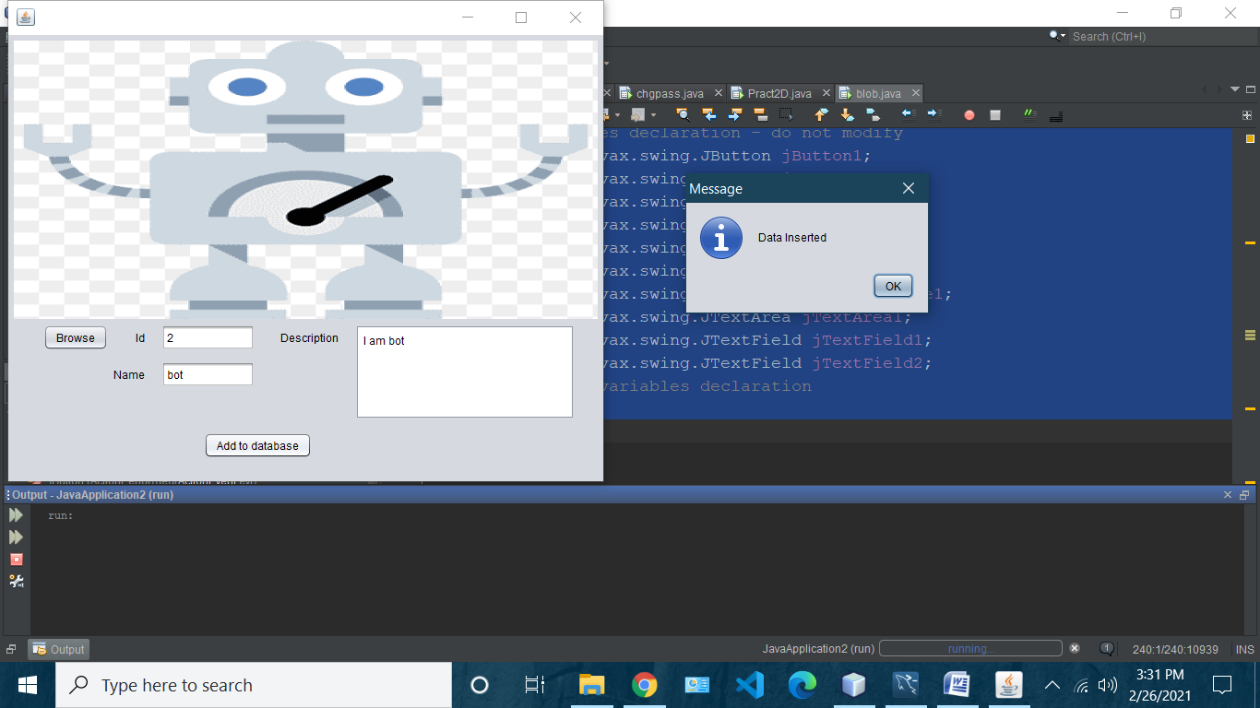

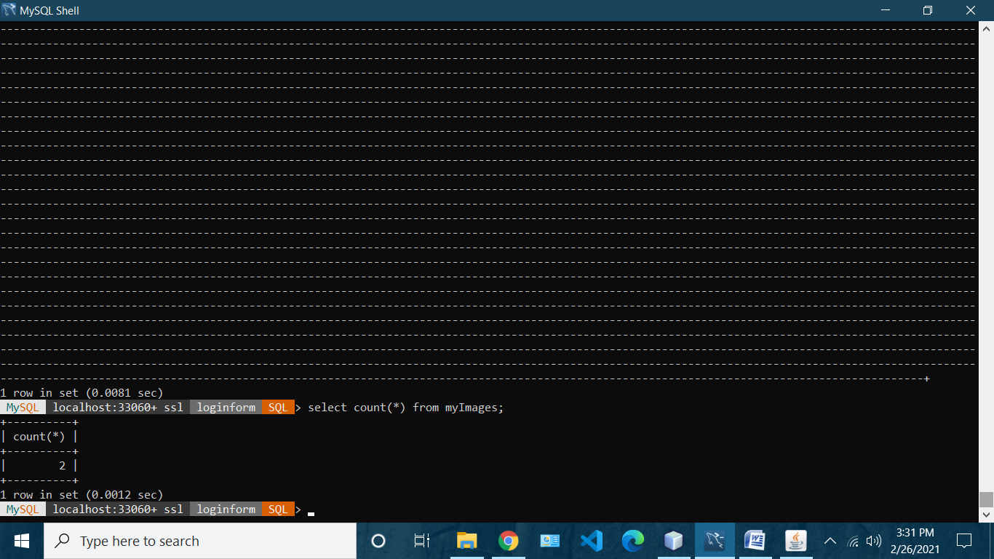

**4B: Retrive from blob**

import java.awt.Image;

import java.sql.Connection;

import java.sql.DriverManager;

import java.sql.ResultSet;

import java.sql.SQLException;

import java.sql.Statement;

import java.util.logging.Level;

import java.util.logging.Logger;

import javax.swing.ImageIcon;

/*

* To change this license header, choose License Headers in Project Properties.

* To change this template file, choose Tools | Templates

* and open the template in the editor.

*/

/**

*

* @author bot

*/

public class retriveimage extends javax.swing.JFrame {

/**

* Creates new form retriveimage

*/

public retriveimage() {

initComponents();

}

/**

* This method is called from within the constructor to initialize the form.

* WARNING: Do NOT modify this code. The content of this method is always

* regenerated by the Form Editor.

*/

@SuppressWarnings("unchecked")

// <editor-fold defaultstate="collapsed" desc="Generated Code">

private void initComponents() {

jButton1 = new javax.swing.JButton();

jLabel1 = new javax.swing.JLabel();

jLabel2 = new javax.swing.JLabel();

jTextField1 = new javax.swing.JTextField();

setDefaultCloseOperation(javax.swing.WindowConstants.EXIT_ON_CLOSE);

jButton1.setText("retrive");

jButton1.addActionListener(new java.awt.event.ActionListener() {

public void actionPerformed(java.awt.event.ActionEvent evt) {

jButton1ActionPerformed(evt);

}

});

jLabel2.setText("id");

javax.swing.GroupLayout layout = new javax.swing.GroupLayout(getContentPane());

getContentPane().setLayout(layout);

layout.setHorizontalGroup(

layout.createParallelGroup(javax.swing.GroupLayout.Alignment.LEADING)

.addGroup(layout.createSequentialGroup()

.addGroup(layout.createParallelGroup(javax.swing.GroupLayout.Alignment.LEADING)

.addGroup(layout.createSequentialGroup()

.addGap(123, 123, 123)

.addComponent(jButton1)

.addGap(171, 171, 171)

.addComponent(jLabel2)

.addGap(26, 26, 26)

.addComponent(jTextField1, javax.swing.GroupLayout.PREFERRED_SIZE, 99, javax.swing.GroupLayout.PREFERRED_SIZE))

.addGroup(layout.createSequentialGroup()

.addGap(15, 15, 15)

.addComponent(jLabel1, javax.swing.GroupLayout.PREFERRED_SIZE, 592, javax.swing.GroupLayout.PREFERRED_SIZE)))

.addContainerGap(21, Short.MAX_VALUE))

);

layout.setVerticalGroup(

layout.createParallelGroup(javax.swing.GroupLayout.Alignment.LEADING)

.addGroup(javax.swing.GroupLayout.Alignment.TRAILING, layout.createSequentialGroup()

.addGap(17, 17, 17)

.addComponent(jLabel1, javax.swing.GroupLayout.DEFAULT_SIZE, 333, Short.MAX_VALUE)

.addPreferredGap(javax.swing.LayoutStyle.ComponentPlacement.UNRELATED)

.addGroup(layout.createParallelGroup(javax.swing.GroupLayout.Alignment.BASELINE)

.addComponent(jButton1)

.addComponent(jLabel2)

.addComponent(jTextField1, javax.swing.GroupLayout.PREFERRED_SIZE, javax.swing.GroupLayout.DEFAULT_SIZE, javax.swing.GroupLayout.PREFERRED_SIZE))

.addGap(94, 94, 94))

);

pack();

}// </editor-fold>

private void jButton1ActionPerformed(java.awt.event.ActionEvent evt) {

// TODO add your handling code here:

try {

// TODO add your handling code here:

Connection con=DriverManager.getConnection("jdbc:mysql://localhost:3306/loginform?autoReconnect=true&useSSL=false","root","root");

Statement st=con.createStatement();

ResultSet rs=st.executeQuery("select * from myImages where ID="+jTextField1.getText()+";");

if(rs.next()){

byte [] img=rs.getBytes("Image");

//resize

ImageIcon image=new ImageIcon(img);

Image im=image.getImage();

Image myImg=im.getScaledInstance(jLabel1.getWidth(),jLabel1.getHeight(),Image.SCALE_SMOOTH);

ImageIcon newImage=new ImageIcon(myImg);

jLabel1.setIcon(newImage);

}

}

catch (SQLException ex) {

Logger.getLogger(retriveimage.class.getName()).log(Level.SEVERE, null, ex);

}

}

/**

* @param args the command line arguments

*/

public static void main(String args[]) {

/* Set the Nimbus look and feel */

//<editor-fold defaultstate="collapsed" desc=" Look and feel setting code (optional) ">

/* If Nimbus (introduced in Java SE 6) is not available, stay with the default look and feel.

* For details see http://download.oracle.com/javase/tutorial/uiswing/lookandfeel/plaf.html

*/

try {

for (javax.swing.UIManager.LookAndFeelInfo info : javax.swing.UIManager.getInstalledLookAndFeels()) {

if ("Nimbus".equals(info.getName())) {

javax.swing.UIManager.setLookAndFeel(info.getClassName());

break;

}

}

} catch (ClassNotFoundException ex) {

java.util.logging.Logger.getLogger(retriveimage.class.getName()).log(java.util.logging.Level.SEVERE, null, ex);

} catch (InstantiationException ex) {

java.util.logging.Logger.getLogger(retriveimage.class.getName()).log(java.util.logging.Level.SEVERE, null, ex);

} catch (IllegalAccessException ex) {

java.util.logging.Logger.getLogger(retriveimage.class.getName()).log(java.util.logging.Level.SEVERE, null, ex);

} catch (javax.swing.UnsupportedLookAndFeelException ex) {

java.util.logging.Logger.getLogger(retriveimage.class.getName()).log(java.util.logging.Level.SEVERE, null, ex);

}

//</editor-fold>

/* Create and display the form */

java.awt.EventQueue.invokeLater(new Runnable() {

public void run() {

new retriveimage().setVisible(true);

}

});

}

// Variables declaration - do not modify

private javax.swing.JButton jButton1;

private javax.swing.JLabel jLabel1;

private javax.swing.JLabel jLabel2;

private javax.swing.JTextField jTextField1;

// End of variables declaration

}

**Output**

